**CDAC MUMBAI**

**Concepts of Operating System**

**Assignment 2**

**Part A**

**What will the following commands do?**

• echo "Hello, World!"

-echo use for print

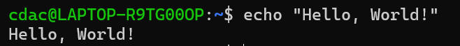

• name="Productive**"**

**-**name use for save

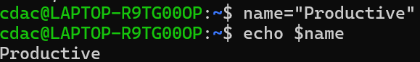

• touch file.txt

-touch use for create a file

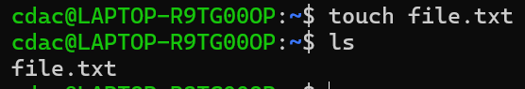

• ls -a

- for display all hidden file



• rm file.txt

- for delete txt file



• cp file1.txt file2.txt

-For copy content file1.txt to file2.txt

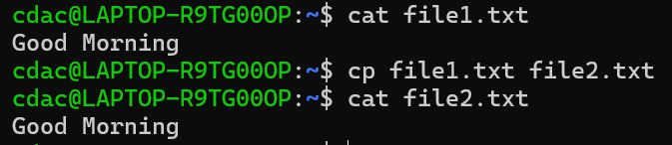

• mv file.txt /path/to/directory/

- for move file to directory

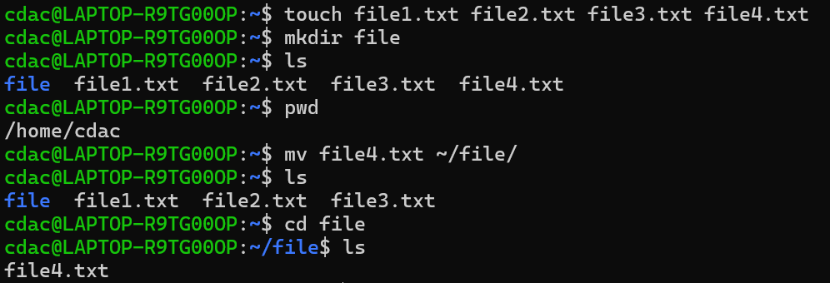

• chmod 755 script.sh

-for change read and execute permission

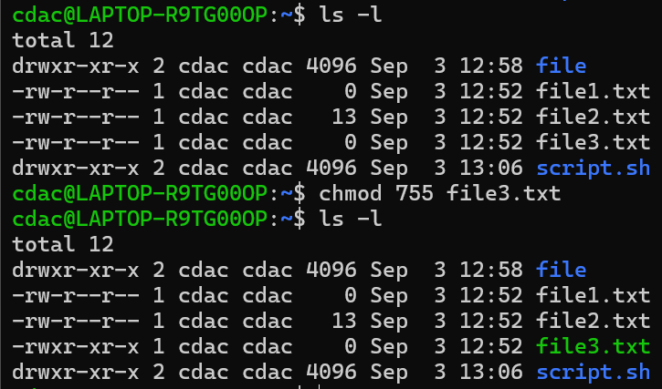

• grep "pattern" file.txt

- for highlight the specific word

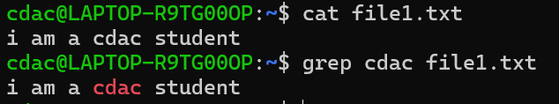

• ls -l | grep ".txt"

-for disply the permission of file

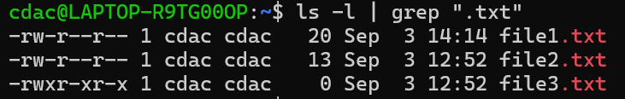

• cat file1.txt file2.txt | sort | uniq



• ls -l | grep "^d"

-List all directory list.

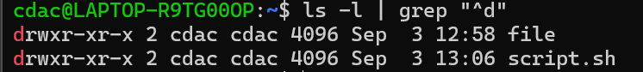

• find /path/to/search -name "*.txt"

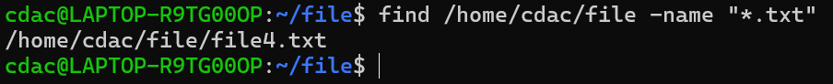

• chmod u+x file.txt

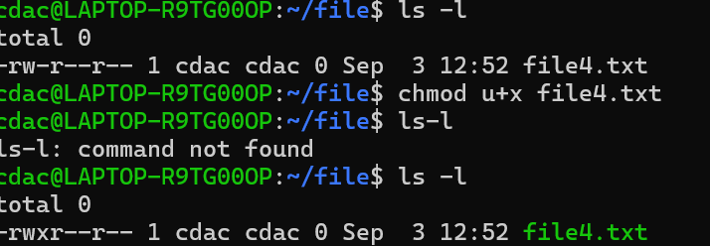

• echo $PATH



**PART – 2**

**Identify True or False:**

1. ls is used to list files and directories in a directory. - TRUE

2. mv is used to move files and directories. – TRUE

3. cd is used to copy files and directories. - FALSE

4. pwd stands for "print working directory" and displays the current directory. - TRUE

5. grep is used to search for patterns in files. - TRUE

6. chmod 755 file.txt gives read, write, and execute permissions to the owner, and read and execute permissions to group and others. - TRUE

7. mkdir -p directory1/directory2 creates nested directories, creating directory2 inside directory1 if directory1 does not exist. - TRUE

8. rm -rf file.txt deletes a file forcefully without confirmation. – TRUE

**Identify the Incorrect Commands:**

1. chmodx is used to change file permissions. - chmod

2. cpy is used to copy files and directories. - cp

3. mkfile is used to create a new file. – touch, nano

4. catx is used to concatenate files. - cat

5. rn is used to rename files. – mv

**Part C**

Question 1: Write a shell script that prints "Hello, World!" to the terminal

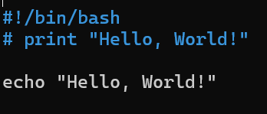

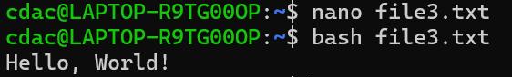

Question 2: Declare a variable named "name" and assign the value "CDAC Mumbai" to it. Print the value of the variable.

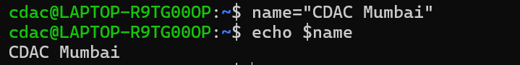

Question 3: Write a shell script that takes a number as input from the user and prints it.

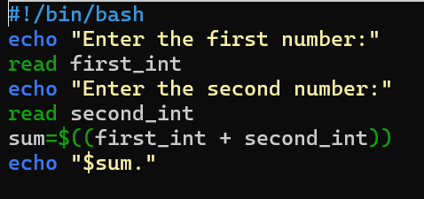

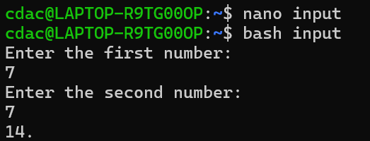

Question 4: Write a shell script that performs addition of two numbers (e.g., 5 and 3) and prints the result.



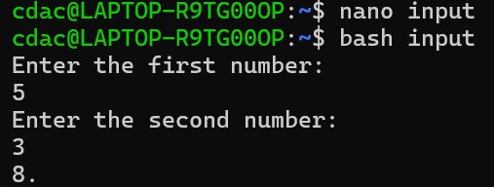

Question 5: Write a shell script that takes a number as input and prints "Even" if it is even, otherwise prints "Odd".

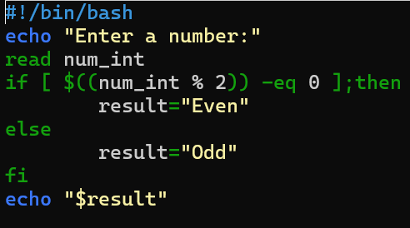

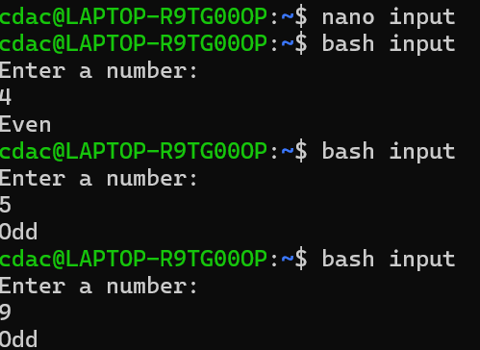

Question 6: Write a shell script that uses a for loop to print numbers from 1 to 5.

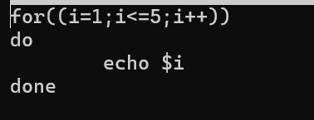

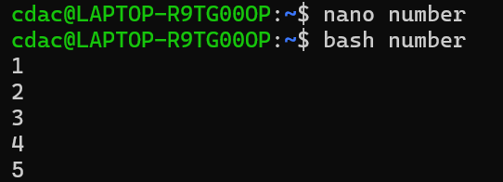

Question 7: Write a shell script that uses a while loop to print numbers from 1 to 5.

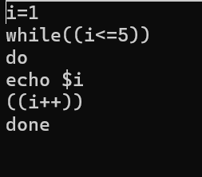

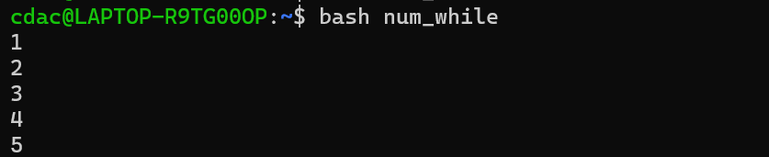

Question 10: Write a shell script that uses nested for loops to print a multiplication table for numbers from 1 to 5. The output should be formatted nicely, with each row representing a number and each column representing the multiplication result for that number.

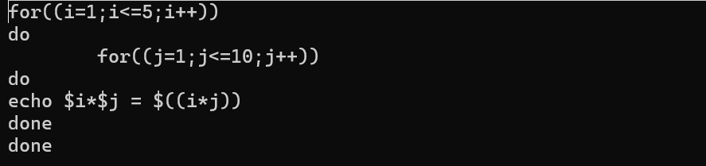

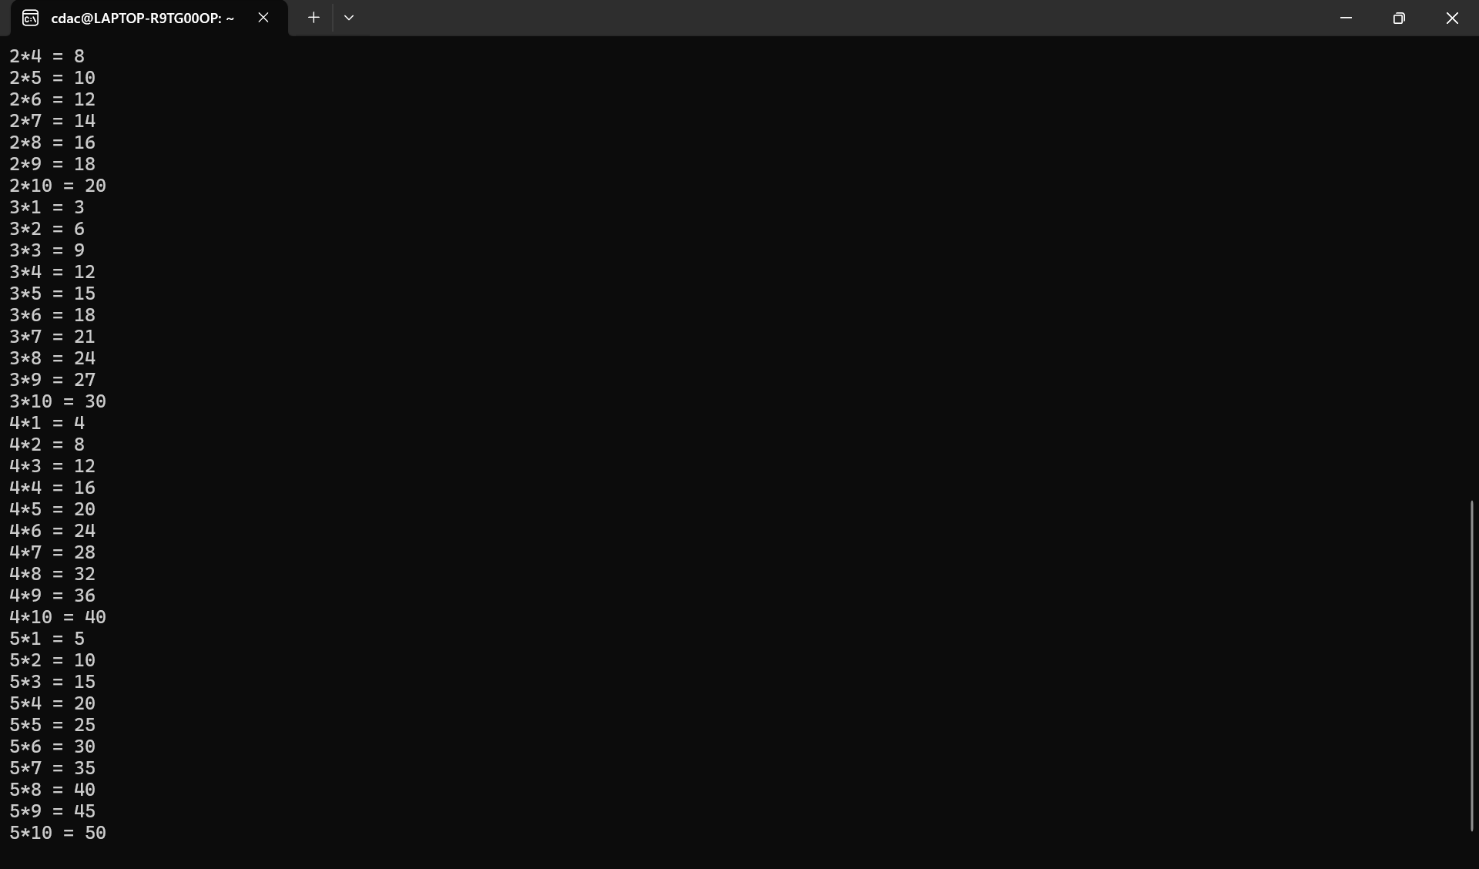

**PART E**

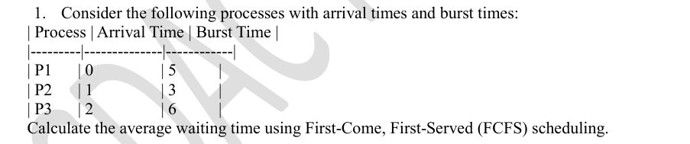

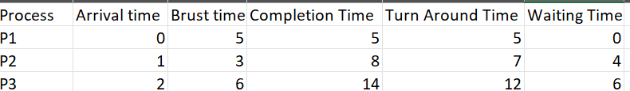

**A**verage waiting time- 10 %3 =3.33